# Media and buffer part

1) Introduction

Activities involving media preparation are carried out in separate rooms by operators who are outfitted with appropriate protective equipment. Because of the high particle concentration of this combination of dry media and buffer component, rooms are classified as hygienic zone D and are found on the ground floor. In this study case four products A, B, C, and D with the amount of 19, 17, 28 and 9, respectively were taken into account. The medium preparation consists of 1000 L tank and 2000L tank and is 37 m2. For the buffer preparation room there are it several tanks, in particular 50L, 100L, 500L, 1000L, 1500L, 2000L, 3000L in the area of 192 m2. The buffer cold storage room consists of 124 m2(see Table: Size and Function of Media and Buffer Systems in Appendix).

2) Buffer estimation

During this process, 72 batches per year were carried out for the four different products (A, B, C, D) which makes about 2 batches per week. Due to safety reasons and uncomplicated usage, the inline dilution system was used, except for the buffers D5, D13 and D18.

Inline dilution is a process of transferring buffer concentrate, through an aseptic transport system, and diluting it with water directly at the site of use. As a result of using this technique, the efficiency and flexibility are exceeded. It enables to lower facility’s footprint, as well as reduced utilities and equipment costs in the long run. One of the biggest disadvantages is the insurance of the quality of mixed buffer, due to physical difficulties with controlling it. (*Ispe.Org*, 2019)

Beschriftung: Calculations of the required volumes of the different buffers per batch.

|  |  |  |  |  |  |
| --- | --- | --- | --- | --- | --- |
| **Number** | **Buffer** | **Volume per batch [L]** | **Volume per two batch (one week) [L]** | **Volume concentrate per week [L]** | **Storage** |
| D1 | Wash 1 Buffer Chroma I | 6776 | 13552 | 2711 | 3000 |
| D2 | Wash 2 Buffer Chroma I | 3080 | 6160 | 1232 | 1500 |
| D3 | Wash 3 Buffer Chroma I | 3080 | 6160 | 1232 | 1500 |
| D4 | Elution Buffer Chroma I | 4312 | 8624 | 1725 | 2000 |
| D5 | NaOH 1M | 960 | 1920 | - | 2000 |
| D6 | Regeneration Buffer Chroma III | 2304 | 4608 | 922 | 1000 |
| D7 | Equilibration Buffer Chroma III | 3006 | 6012 | 1202 | 1500 |
| D8 | Pre-/ Sanitization Buffer Chroma III | 1816 | 3632 | 726 | 1000 |
| D9 | Wash Buffer 2 Chroma II | 1135 | 2270 | 454 | 500 |
| D10 | Elution Buffer Chroma II | 1589 | 3178 | 636 | 1000 |
| D11 | Strip Buffer Chroma II | 681 | 1362 | 272 | 400 |
| D12 | Equilibration Buffer Chroma III | 833 | 1666 | 333 | 400 |
| D13 | Equilibration / Flush Buffer Nano Filtration | 251 | 502 | - | 400 |
| D14 | Diafiltration Buffer UF/DF2 | 4099 | 8198 | 1640 | 2000 |
| D15 | Acid Buffer Viral Inactivation | 154 | 308 | 62 | 100 |
| D16 | Base Buffer Viral Inactivation | 161 | 322 | 64 | 100 |
| D17 | Chroma I Storage Buffer 20% EtOH | 924 | 1848 | 370 | 400 |
| D18 | pH Adjustment Buffer | 226 | 452 | - | 500 |
| D50 | NaOH 0.01 M Storage Buffer | 852 | 1704 | 341 | 400 |
| D51 | NaOH 0.5 M | 431 | 862 | 172 | 200 |
| D53 | NaOH 0.1 M | 340 | 680 | 136 | 200 |

2) Plant on a page of Media and Buffer preparation 🡪 Dzenneta

Media and feed preparation has an important role in this process and especially for the upstream process that follows. The following volumes of media and feed are required for the different bioreactors during the process:

Image: Volume data for medium and feed for the entire process

|  |  |  |
| --- | --- | --- |
| Bioreactor | **Media** Volume/batch [L] | **Feed** Volume/batch [L] |
| Seed Bioreactor 1 | 16 | 4 |
| Seed Bioreactor 2 | 160 | 40 |
| Production Bioreactor | 3x 1600 | 3x 400 |

The medium and feed are prepared in stirred tanks and then distributed into transportable bags, where each bioreactor in the upstream process receives the corresponding volume size. The plant on a page is showed on IMAGE ?.

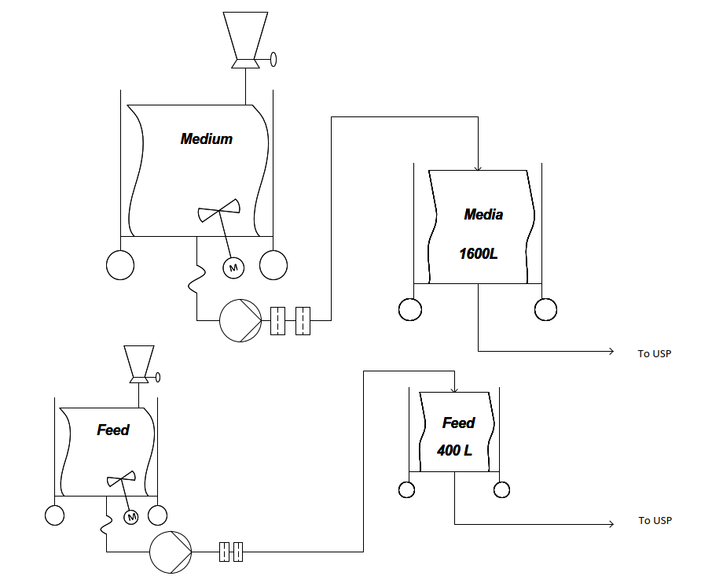

Image: Plant on a page of media and feed preparation for the USP. Image created with Visio®.

Based on the calculations for the buffer preparation, a plant on a page (IMAGE ?) was designed. Each buffer concentrate is produced in a large production reactor and then stored in a tank. The transport of the buffers to the DSP takes place through the inline dilution system. Buffer D5, D13 and D18 are transported through transportable bags and all other buffers through hard pipes.

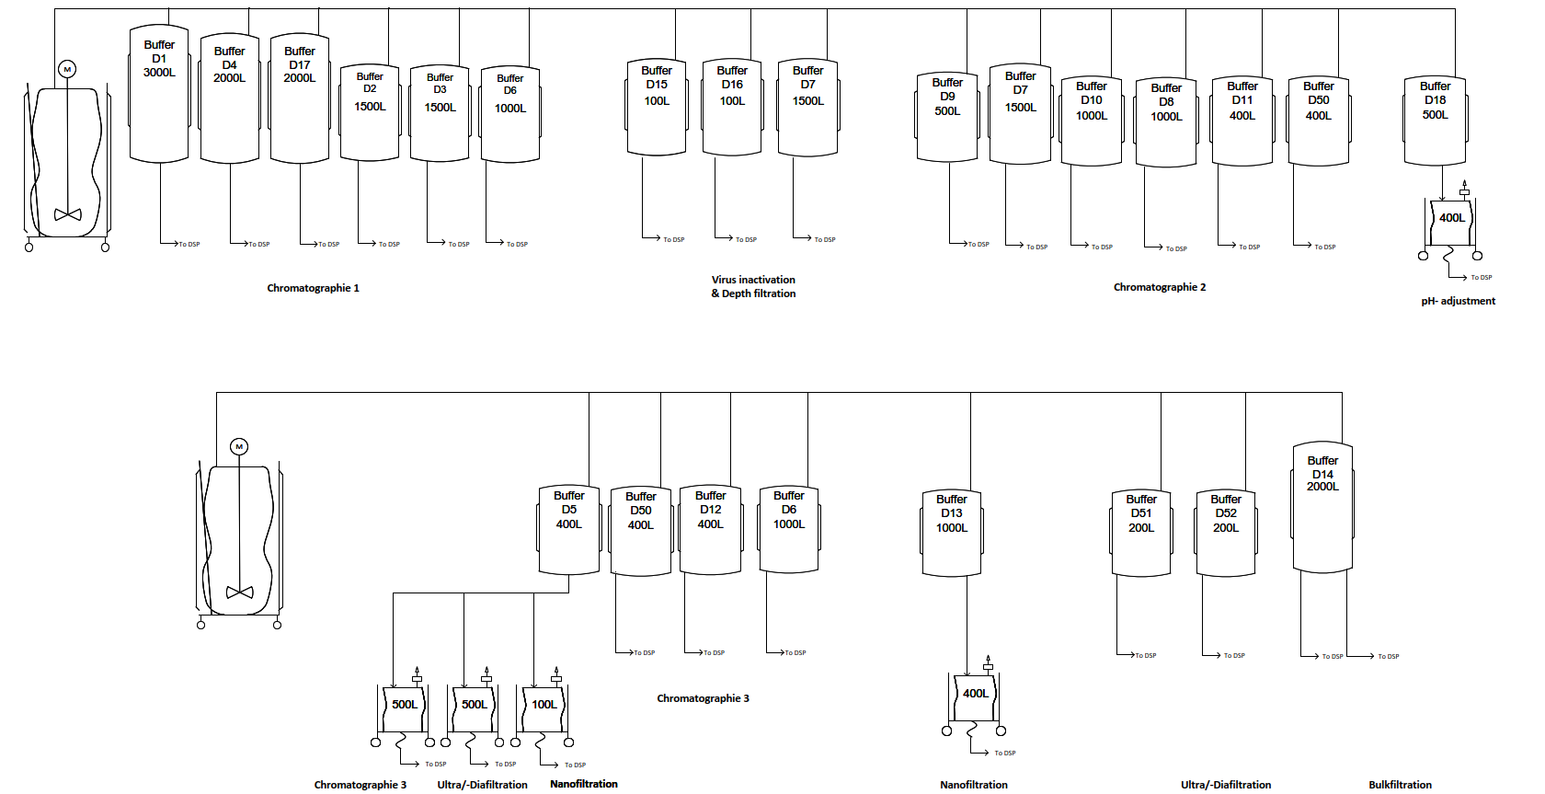

Image: Plant on a page of buffer preparation for the DSP. Image created with Visio®.

3) Hakobio Room Concept

of Media preparation à Natalia

**Room concept of Media & feed preparation & storage room**

The room has 37 m2 and is placed close to the USP production, to enable easier and shorter transport of already prepared media and feed to the upstream production. All the used tanks are going to be mobile, and ready for transit of needed materials.

4) Hakobio Room Concept of Buffer preparation 🡪 Natalia

**Room concept of Buffer preparation & storage**

The buffer preparation has 192 m2 and storage room has 124 m2 and is right next to the DPS production. The inline dilution system will be used for 18 out of 21 buffers, which made it necessary to place those two rooms close to each other so that the process of transferring buffer into downstream production does not disturb other production steps or the work organization of the whole facility. Despite the current trend of working with single-use technologies, we have decided to use regular tanks for preparation and storage, due to the very small variation of the used buffers in between the products.

The equipment needed for media and buffer preparation and storage in mAb manufacturing is listed in this paragraph. The table shows the different sorts of materials, as well as their number and size. For the design of a biopharmaceutical facility, a review of the equipment required, and its scale is critical.

Table: Size and Function of Media and Buffer Systems

|  |  |  |  |
| --- | --- | --- | --- |
| **Media and feed storage and preparation room** | | | |
| **Equipment** | **Quantity** | **Size in m** | **Photo** |
| 2000 L Jacketed Cubical Tank with Load Cell | 3 | 1.78 x 1.39 x 2.65 | 2000 L Jacketed Cubical Tank with Load Cell |
| 200 L stainless steel Bioreactor with Trolley | 1 | 0.82 x 0.65 x 1.2 |  |
| 2 x 20 L Biocontainers with Trolley | 1 | 0.71x1.05x0.98 | Ein Bild, das Vervielfältiger enthält.  Automatisch generierte Beschreibung |
| 500 L formulation tank | 3 | 0.72 x 0.83 x 1.39 | Formulation tank |
| 100 L Jacketed Cubical Tank with Load Cell, Stainless Steel | 1 | 1 x 0.86 x 1.58 | Ein Bild, das Tisch enthält.  Automatisch generierte Beschreibung |

|  |  |  |  |
| --- | --- | --- | --- |
| **Buffer storage and preparation room** | | | |
| **Equipment** | **Quantity** | **Size in m** | **Photo** |
| 3000 L Jacketed Cubital Tank with Load Cell | 1 | 1.64 x 1.40 x 3.56 | 3000 L Jacketed Cubital Tank with Load Cell |
| 2000 L Jacketed Cubical Tank with Load Cell | 2 | 1.78 x 1.39 x 2.65 | 2000 L Jacketed Cubical Tank with Load Cell |
| 1500 L Jacketed Cubical Tank with Load Cell | 3 | 1.62 x 1.39 x 2.17 | 1500 L Jacketed Cubical Tank with Load Cell |
| 1000 L Jacketed Cubical Tank with Load Cell | 3 | 1.53 x 1.29 x 1.60 | 1000 L Jacketed Cubical Tank with Load Cell |
| 500 L Formulation tank | 4 | 0.72 x 0.83 x 1.39 | Formulation tank |
| 400 L Jacketed Cubical Tank with Load Cell | 5 | 1.27 x 1.01 x 1.58 | 400 L Jacketed Cubical Tank with Load Cell |
| 200 L stainless steel Bioreactor with Trolley | 3 | 0.82 x 0.65 x 1.2 |  |
| 100 L stainless steel Tank | 3 | 1.00 x 0.86 x 1.58 |  |

Table: Calculations of the required volumes of the different buffers per batch.

|  |  |  |  |  |  |
| --- | --- | --- | --- | --- | --- |
| **Number** | **Buffer** | **Product A**  Volume/batch [L] | **Product B**  Volume/batch [L] | **Product C**  Volume/batch [L] | **Product D**  Volume/batch [L] |
| D1 | Wash 1 Buffer Chroma I | 6776 | 6776 | 6776 | 6776 |
| D2 | Wash 2 Buffer Chroma I | 3080 | 3080 | 3080 | 3080 |
| D3 | Wash 3 Buffer Chroma I | 3080 | 3080 | 3080 | 3080 |
| D4 | Elution Buffer Chroma I | 4312 | 4312 | 4312 | 4312 |
| D5 | NaOH 1M | 960 | 960 | 960 | 960 |
| D6 | Regeneration Buffer Chroma III | 2304 | 2304 | 2304 | 2304 |
| D7 | Equilibration Buffer Chroma III | 3006 | 3006 | 3006 | 3006 |
| D8 | Pre-/ Sanitization Buffer ChromaIII | 1816 | 1816 | 1816 | 1816 |
| D9 | Wash Buffer 2 Chroma II | 1135 | 1135 | 1135 | 1135 |
| D10 | Elution Buffer Chroma II | 1589 | 1589 | 1589 | 1589 |
| D11 | Strip Buffer Chroma II | 681 | 681 | 681 | 681 |
| D12 | Equilibration Buffer Chroma III | 833 | 833 | 833 | 833 |
| D13 | Equilibration / Flush Buffer Nano Filtration | 251 | 251 | 251 | 251 |
| D14 | Diafiltration Buffer UF/DF2 | 4099 | 4099 | 4099 | 4099 |
| D15 | Acid Buffer Viral Inactivation | 154 | 154 | 154 | 154 |
| D16 | Base Buffer Viral Inactivation | 161 | 161 | 161 | 161 |
| D17 | Chroma I Storage Buffer 20% EtOH | 924 | 924 | 924 | 924 |
| D18 | pH Adjustment Buffer | 226 | 226 | 226 | 226 |
| D50 | NaOH 0.01 M Storage Buffer | 852 | 852 | 852 | 852 |
| D51 | NaOH 0.5 M | 431 | 431 | 431 | 431 |
| D53 | NaOH 0.1 M | 340 | 340 | 340 | 340 |

Sources

*ispe.org*. (2019). <https://ispe.org/pharmaceutical-engineering/may-june-2019/inline-dilution-agile-capability-downstream-manufacturing>

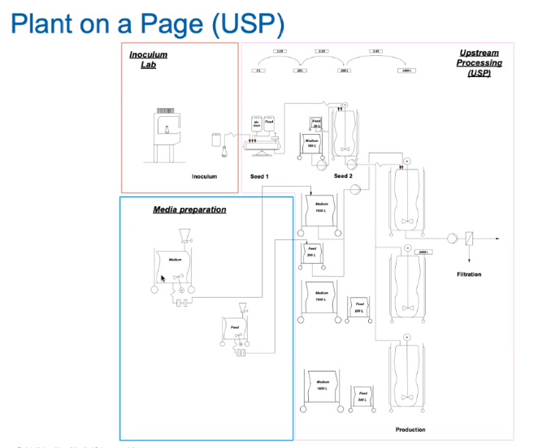

Ein Bild, das Tisch enthält.
